**How to set up a Take ACCTion Enthuse fundraising page**

Please go to our Take ACCTion Campaign page <https://armycadets.enthuse.com/cf/takeacction>

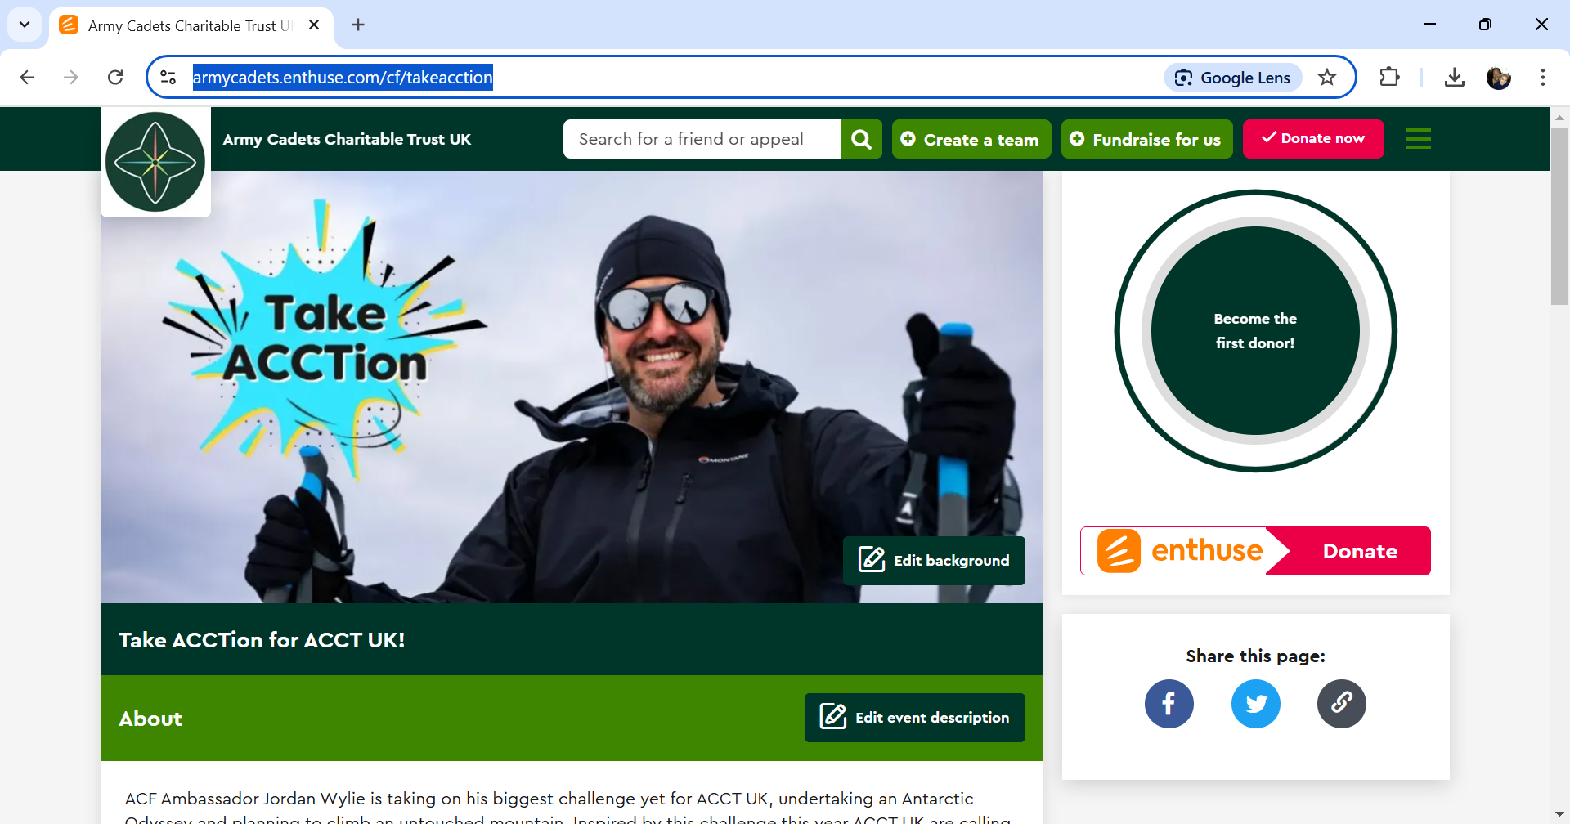

Create your team page by clicking on ‘Create a team’ - right of the of the search box in the header banner.

Once you’ve clicked the button to set up a team fundraiser page, you will be taken through the steps below.

**Step 1 - Your Team name**

You'll be asked to name your team here.

[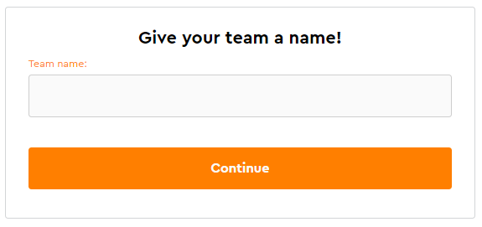](https://downloads.intercomcdn.com/i/o/807106534/51611e6178b8fce59caed436/image.png?expires=1746716400&signature=a1a374dad6e00ef2f6e7d125ca99d6607825a6be7c4de63c1395557dce607953&req=fCAgF8l4mIJbFb4f3HP0gC%2BSLVsSbI%2BK%2F2eHbWq1XMtNmfOpKEolMNOKApMI%0Ay6tcvjSfPbWT4Vh7Dg%3D%3D%0A)

**Step 2 - Your Target.**

Here you can choose how much you'd like to fundraise. When you've entered a target, click **Continue**.

[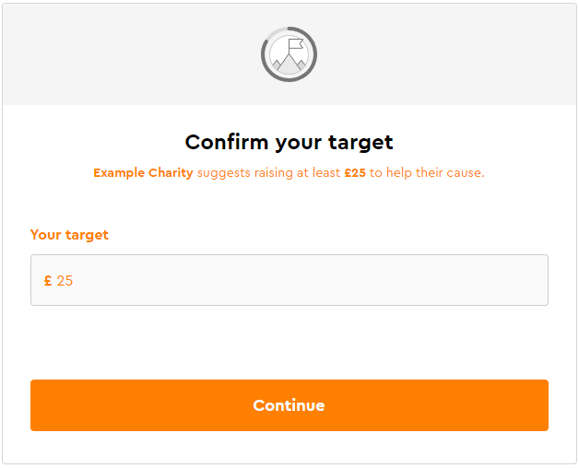](https://downloads.intercomcdn.com/i/o/807001664/7bfe36de35a74299da36c3df/image.png?expires=1746716400&signature=0ed17c4146b78e14d0a03902eaae472f9aa00af5963de9e41efa40a519db9b49&req=fCAgFsl%2Fm4dbFb4f3HP0gBZ7qIzXR7ydmX9qx45o1QFTo1aC2MoiG0tVr1%2Fy%0ActWpwhintvybtDS3%2BA%3D%3D%0A)

**Step 3 - Team logo**

To add a photo, click either **Upload image** or **Upload from Facebook.**  
If you already have a photo and want to replace it, click **Replace profile picture**.  
You can also click "I'll do this later", however, statistically speaking, fundraising pages with a team picture raise more!  
​

[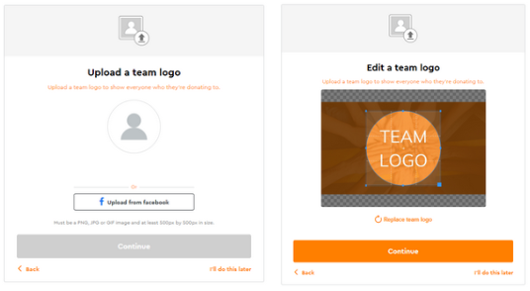](https://downloads.intercomcdn.com/i/o/807114299/fefd5d8660e4a6c912bee1b2/image.png?expires=1746716400&signature=ac868e4ef556d02ab675cb2b3bb7a8654ca8e5c968bb19576519fdeb475c2be9&req=fCAgF8h6n4hWFb4f3HP0gOcWBFS3yOCz4U8svhTsoEKalKtIs%2F6sIKJCDLUf%0A31w2Xa4euTgQ8x1dBg%3D%3D%0A)

When you're happy with your team logo, click **Continue**.

**Step 4 - Background photo**

You can choose to use the default image which is provided by ACCT UK, or **Upload new image.**   
​  
When you're happy with your header image, click **Continue**.

[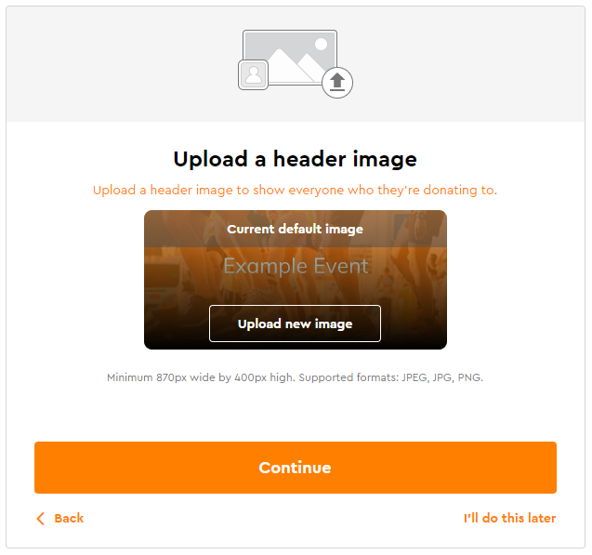](https://downloads.intercomcdn.com/i/o/807013728/def877975300d271b5b347e7/image.png?expires=1746716400&signature=d9147c4ebe160dc2e6f6b3679bb316a40bdb4727ae04a8556fcc943670845497&req=fCAgFsh9moNXFb4f3HP0gFj6oqgq1R1hxcXbGEX6UDW%2FuokdA4r%2Fxlq7gmb9%0AqpnrKuSINYSq03WClQ%3D%3D%0A)

**Step 5 - Tell us about your team**

Here's where you can title your page and tell your story.  
You can even include images, video, and links.

[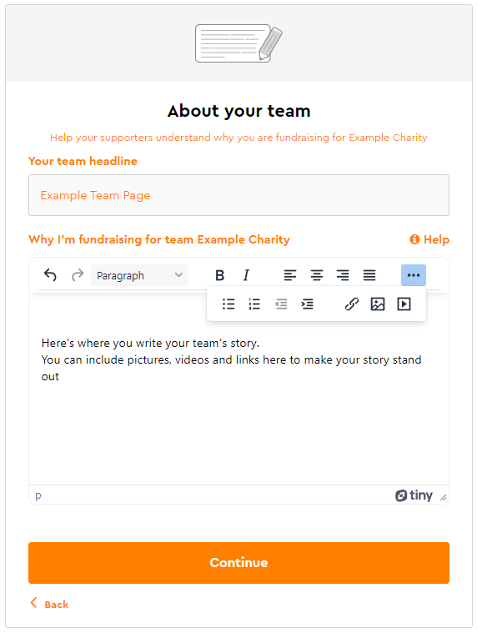](https://downloads.intercomcdn.com/i/o/807117873/6d2ef8833cef87d9b5ff64cc/image.png?expires=1746716400&signature=47346cac687753a6fcf540031a1509cefc83fa32a625424edf77a9b3ba34e9a2&req=fCAgF8h5lYZcFb4f3HP0gDQld7Z9rAMxP70z3eYkbf1BTUKRbnSXjhX17%2FAx%0A65k6TFsjo6ugAcX2Jw%3D%3D%0A)

When you're happy, click **Continue**.

**Step 6 - Customise your team page link**

In some cases, you'll be asked to customise your page link, you can call this whatever you want.

[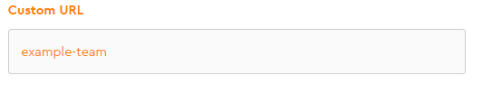](https://downloads.intercomcdn.com/i/o/807119514/2d0364bbad8817cda97b023f/image.png?expires=1746716400&signature=54a917422c77f82525a3f9711854091a1ba60a30dec6fec85a4a48fc9770c080&req=fCAgF8h3mIBbFb4f3HP0gK%2BRAu94zaL%2B%2FLOwIt26YVsX1Av396eEXLDShFz8%0AW9Vq6eT1xi90pHWxmw%3D%3D%0A)

Don't be surprised if you don't get this option, as some charities prefer a more uniform URL.  
Once you're happy with your URL, click Continue

**Step 7 - Marketing preferences.**

You'll be asked if you're happy to be contacted by the charity. Select your preference then click "Continue"

[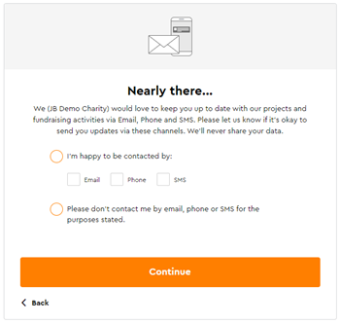](https://downloads.intercomcdn.com/i/o/vkr9i5me/1438458712/c6ad280649ce34e2bcd812c852f5/fundraising+new+mps+step+mar+25.png?expires=1746716400&signature=db2dff4f79daae2e8338b65316281dac1308edbc7391fe66dfd8dcb631043247&req=dSQkHs17lYZeW%2FMW1HO4zaq7BItW73%2BIYPNvYvBwneY69dgkkVMHhmDpWvep%0A2blq%2FgKxMjo0xIemyVY%3D%0A)

**Step 8 - Spread the word**

Congratulations! Your fundraising page is complete.  
Here's where you can share your page directly to Facebook and X (formerly Twitter), or copy your page URL to send elsewhere.  
Here you can either preview your page, or click finish if you're done.

[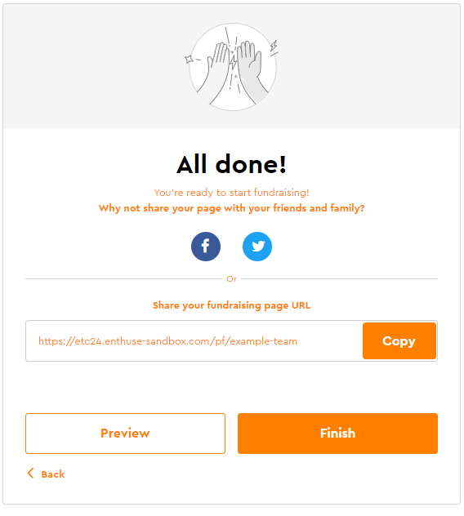](https://downloads.intercomcdn.com/i/o/807120809/2624c24b62e224539c4a5de2/image.png?expires=1746716400&signature=62bb649a628d55f5af6e352bde852aec17db1121419036473934e4dee69cb7a9&req=fCAgF8t%2BlYFWFb4f3HP0gNpS%2FobDNv%2BOS6yxmXc50KRA4OdpUC2BOd%2FoDHfh%0A%2BWuEHCxvoVyYtz7Y6Q%3D%3D%0A)

**Step 9 - Invite your friends!**

Your team has been successfully created.   
Now send the link to them to get them to join your team!

[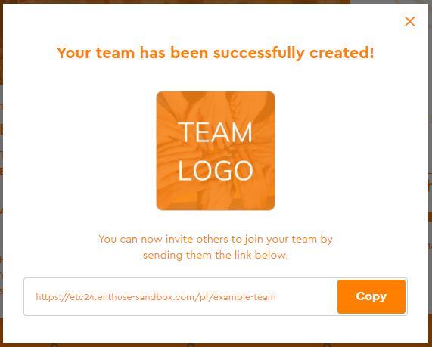](https://downloads.intercomcdn.com/i/o/807121775/c19632883cad2ec056e2bdde/image.png?expires=1746716400&signature=48b000f561b1fc6c436ff2bb1b7a619e3501b28b9e064dbc7c65dbcd5f51d11b&req=fCAgF8t%2FmoZaFb4f3HP0gLapAGL4gdIIDFJPXGJV6PB0Vv6zzJfg%2B5ClF3BX%0AqhEYqUsmud6DXUBo1w%3D%3D%0A)

If you are having any issues setting up your page or have any questions about fundraising, then please contact the ACCT UK Fundraising Manager on [fundraising@acctuk.org](mailto:fundraising@acctuk.org)